MACH4METAL

Metalworking machinery
Transito 21,
6909 DA BABBERICH
Netherlands
Tel. +31 (0)316 – 247123
Fax. +31 (0)316 - 247956
info@mach4metal.com
www.mach4metal.com

Account No: 66.52.13.883
IBAN : NL33 INGB 0665 2138 83
BIC : INGBNL2A

CETOS BHU 25 H x 1250 mm
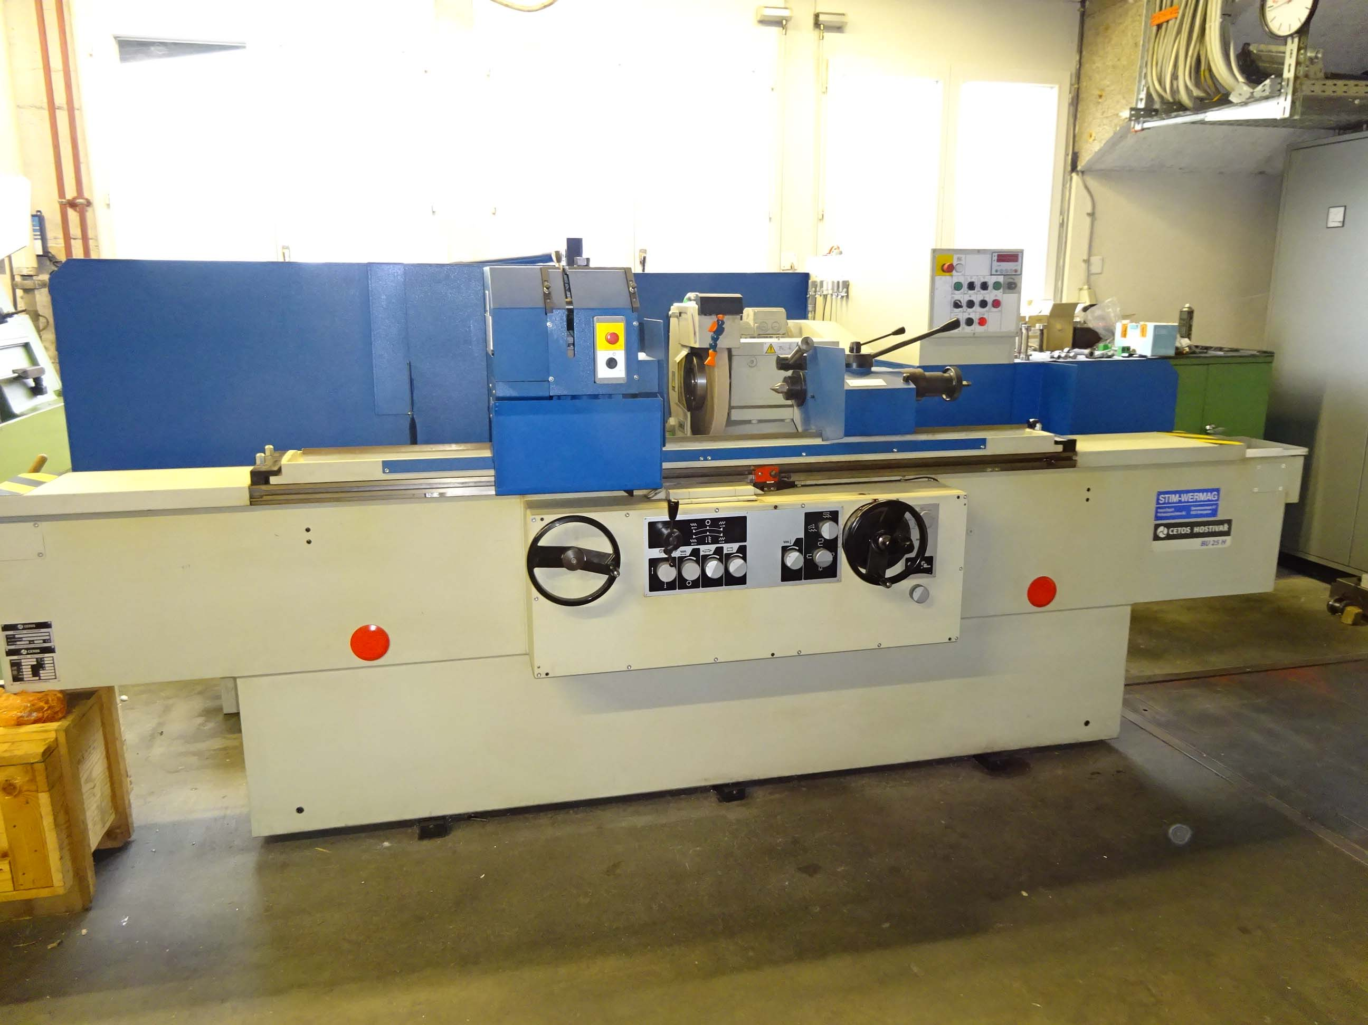
- Make : CETOS CZ
- Typ : BHU 25 H
- Serial :
- Age : 2005

- Grinding diameter : 250
- Centre height : 128
- DBC : 1.250
- Work load Kg : 250

- Work spindle swivel able : +/- 90 Gr
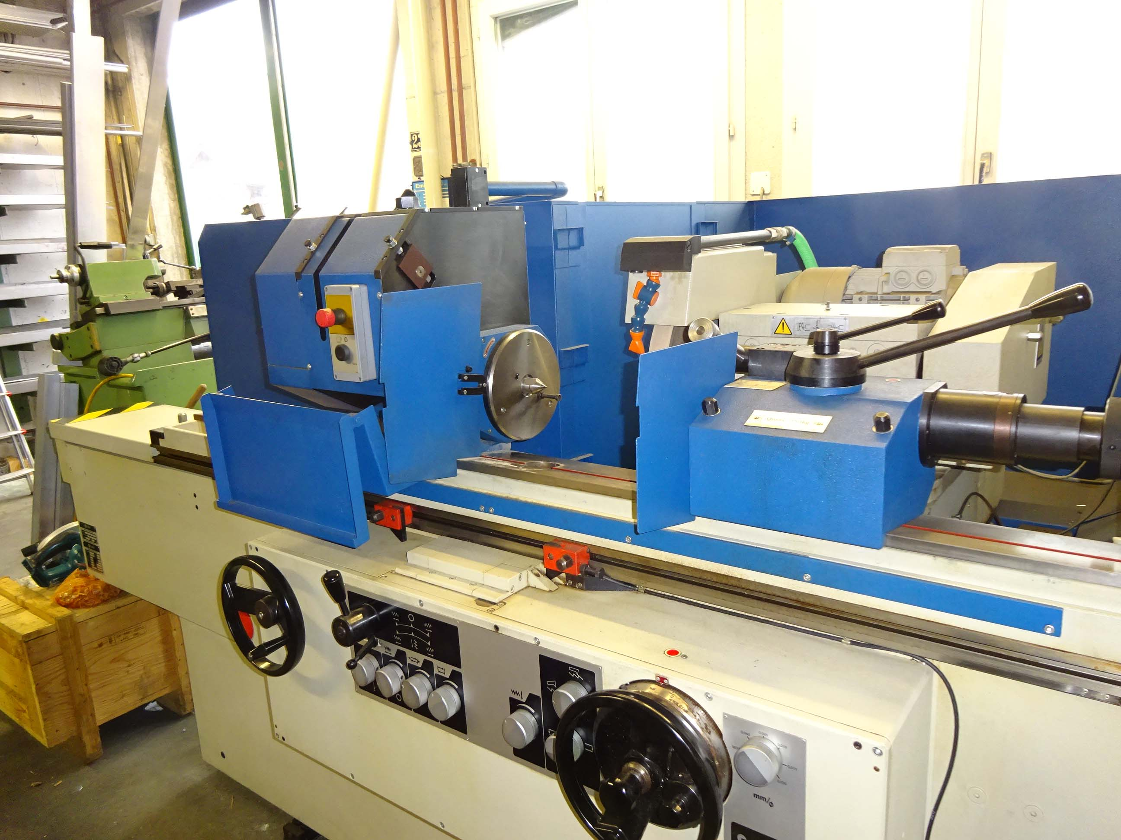
- Work piece spindle bore : Mk 4
- Spindle speeds : 500 U/min

- Grinding head swivel able : +/- 45/15 Gr
- Head adjustment : 330 mm
- Feed range Vario : 0.001 – 315 mm/U

- Stone : 400 x 40 x 127
- Minimum stone Ø 200

- Table travel : 1.508 mm
- Table speeds : 0.005 – 5 M/min
- Table swivel range : 6˚50 / 3˚50

- Dimensions
- Length : 5.000
- Width : 2.800
- Height : 2.200
- Weight : 6.100

Please Note: The above information has been obtained to the best of our ability and belief from, and from the manufacturers where possible. It is given in good faith, but its accuracy can not be guaranteed. Accordingly, it will not form a representation or constitute contractual terms. We advise you to check any vital details

